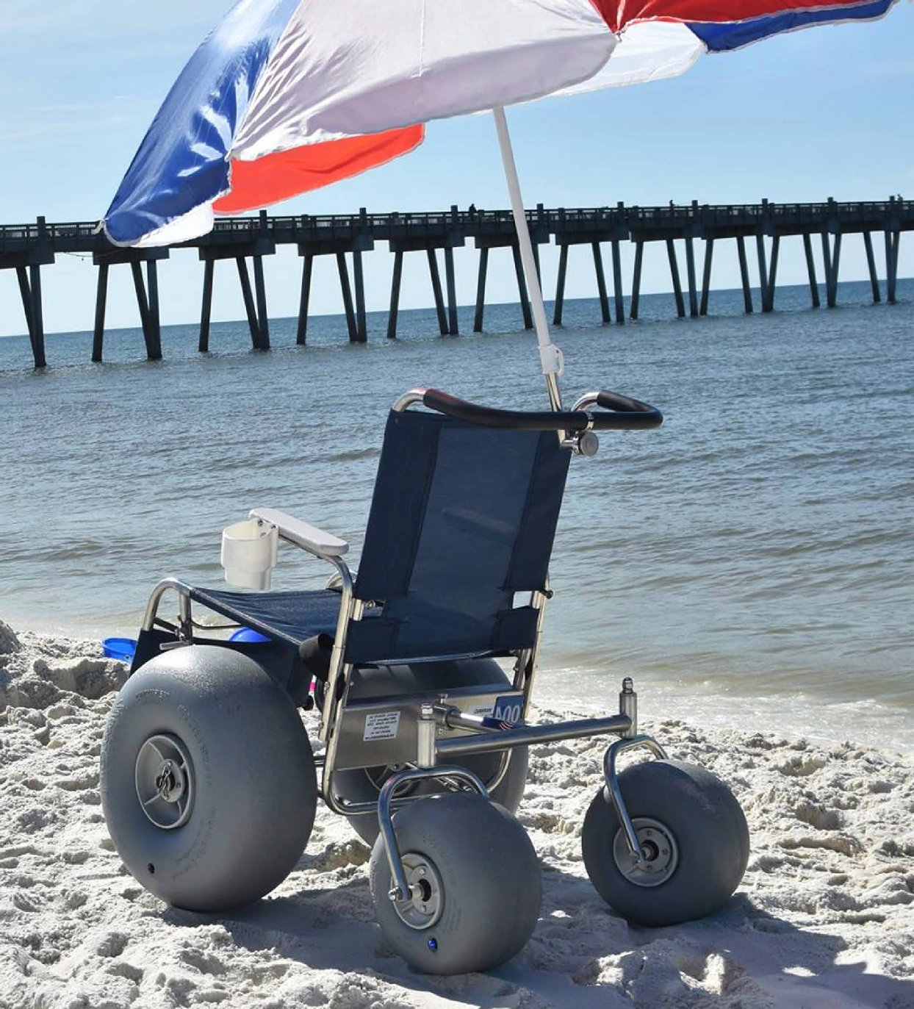DEBUG FIXED FRAME
ALL–TERRAIN WHEELCHAIR

DEBUG FIXED FRAME
ALL–TERRAIN WHEELCHAIR

The Debug Fixed Frame All Terrain Wheelchair is designed to safely provide wheelchair users with transportation across
areas where a conventional wheelchair becomes unmanage­ able. This includes areas such as beaches, snow covered side­ walks, forest trails, etc. Debug is intended to provide decades of service life in the harshest of environments.

LONG LASTING #316L STAINLESS STEEL FRAME / ADJUST- ABLE TELESCOPIC LEG REST / FITS THROUGH A STANDARD
ADA DOORWAY / LOW MAINTENANCE DELRIN BUSHINGS / POLYURETHANE PNEUMATIC WHEELS ROLL ACROSS SAND, SNOW AND GRAVEL / DUAL STITCHED SLING WITH TENERA 130 THREAD / PHIFERTEX PLUS SLING MATERIAL RESISTS
STRETCHING, MILDEW AND BACTERIA, COLD CRACK AND ULTRAVIOLET DAMAGE AND IS MACHINE WASHABLE.

SPECIFICATIONS

SEAT SIZES | ENGLISH (INCH) | METRIC (CM)
Widths | 14, 18, 22 | 36, 46, 56
Average depth | 17 | 43
Seat-to-floor height | 17 – 21 | 43 – 53
Backrest height | 18 | 46

Telescope footrest
knee to heel
Elevating leg rest
knee to heel
15 – 22 38 – 56

15 – 22 38 – 56

ORDER ONLINE WWW.DEBUGMOBILITYPRODUCTS.COM
WEIGHTS

Capacity 250 – 400 lbs 114 – 182 kg

Chair weight 40 – 65 lbs 18 – 30 kg

Manufactured in the USA,
Debug has a 10 year warranty on stainless steel frames and a 30 day money back guarantee.
© Copyright Deming Designs Inc., 2001–2016. All rights reserved.

ARMREST STYLES
Removable swing away armrest Adjustable height or padded optional

”Contoured“ or specialized optional

Interchangeable desk option available

